Table of Contents
[To update the table of contents, select the message below and press F9]

1. Pages 2
1.1. Page Tree 2
1.2. Admin 3
1.2.1. User Interface 3
1.2.2. Object Table 3
1.2.3. EditCategory 4
1.2.3.1. State1 4
1.2.4. CatList 5
1.2.4.1. State1 5
1.2.5. Are You Sure Message 6
1.2.5.1. State1 6
1.2.6. Changes Saved 6
1.2.6.1. State1 6
1.2.7. Select At Least One Message 6
1.2.7.1. State1 6
1.3. Profile 8
1.3.1. User Interface 8
1.3.2. Object Table 8
1.3.3. panel - street address error 9
1.3.3.1. enter street address 9
1.3.4. panel - city state zip error 9
1.3.4.1. enter city, state, and zip 9
2. Masters 10
2.1. Master List 10

- Pages
  - Page Tree
- Admin
- Profile
  - Admin
Admin page to manage categories. Displays all active categories by default.
Checked off items in the list can be deleted with the Delete button on the toolbar.
    - User Interface
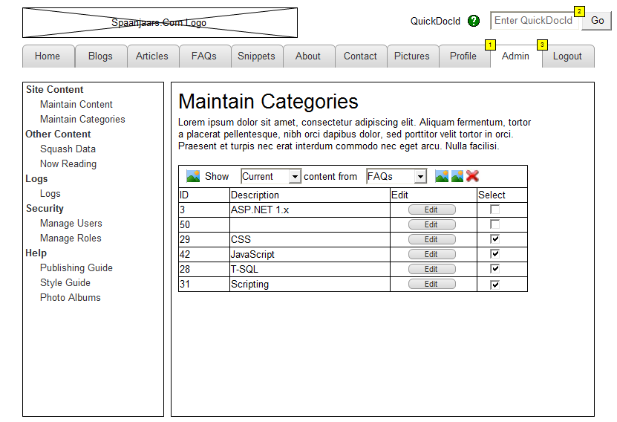
    - Object Table
Footnote | Label | Interactions | Description | Risk | Target Release | Assigned To | Area
1 | tab | OnClick:  Case 1:  Open Profile in Current Window
2 | text field | OnFocus:  Case 1 (If text on widget text field equals "Enter QuickDocId"):  Set text on widget text field equal to ""  OnLostFocus:  Case 1 (If text on widget text field equals ""):  Set text on widget text field equal to "Enter QuickDocId"
3 | Admin Tab |  | Main Admin tab; only visible when logged in with Admin privileges | Medium | 1 | Imar | Back end
    - EditCategory
      - State1
User Interface
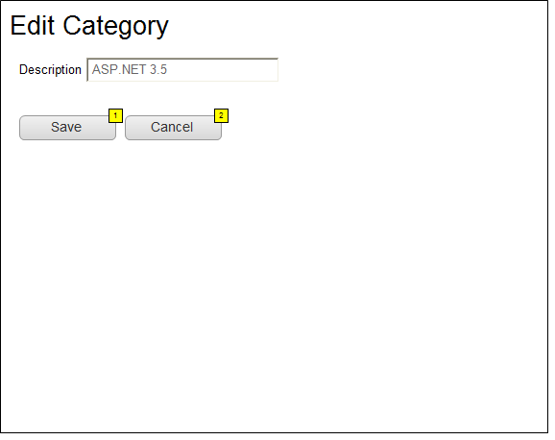
Object Table
Footnote | Label | Interactions
1 | button | OnClick:  Case 1:  Show CatList, Changes Saved  Hide EditCategory  Wait 2500 ms  Hide Changes Saved
2 | button | OnClick:  Case 1:  Show CatList  Hide EditCategory
    - CatList
      - State1
User Interface
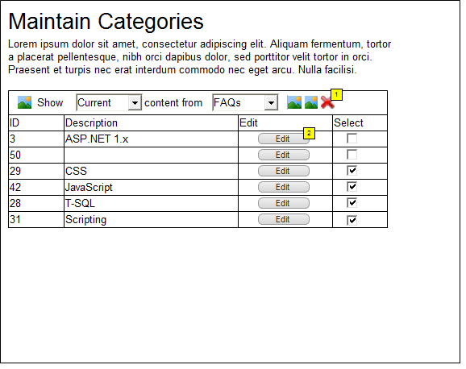
Object Table
Footnote | Label | Interactions | Description | Area
1 |  | OnClick:  Case 1 (If is checked of Check2 equals true or is checked of Check1 equals true or is checked of Check3 equals true or is checked of Check4 equals true or is checked of Check5 equals true or is checked of Check6 equals true):  Show Are You Sure Message  Case 2 (Else If True):  Show Select At Least One Message | Delete selected categories | Back end
2 | button | OnClick:  Case 1:  Show EditCategory  Hide CatList
    - Are You Sure Message
      - State1
User Interface
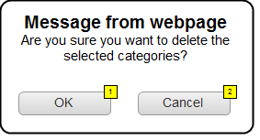
Object Table
Footnote | Label | Interactions
1 | button | OnClick:  Case 1:  Hide Are You Sure Message
2 | button | OnClick:  Case 1:  Hide Are You Sure Message
    - Changes Saved
      - State1
User Interface
    - Select At Least One Message
      - State1
User Interface
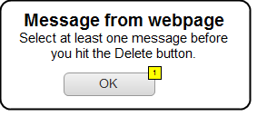
Object Table
Footnote | Label | Interactions
1 | button | OnClick:  Case 1:  Hide Select At Least One Message
  - Profile
    - User Interface
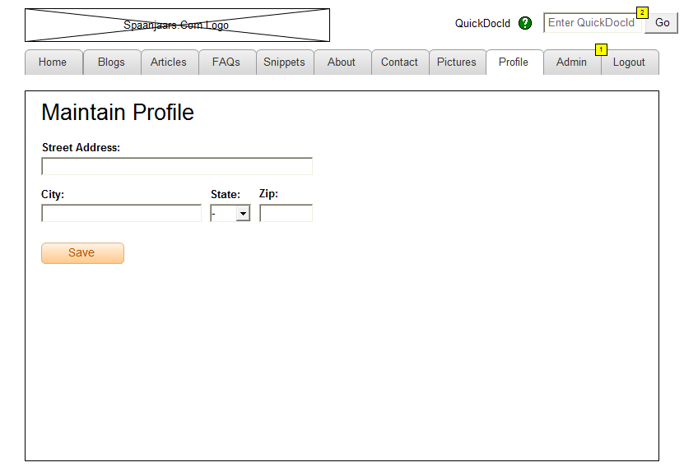
    - Object Table
Footnote | Label | Interactions
1 | tab | OnClick:  Case 1:  Open Admin in Current Window
2 | text field | OnFocus:  Case 1 (If text on widget text field equals "Enter QuickDocId"):  Set text on widget text field equal to ""  OnLostFocus:  Case 1 (If text on widget text field equals ""):  Set text on widget text field equal to "Enter QuickDocId"
    - panel - street address error
      - enter street address
User Interface
    - panel - city state zip error
      - enter city, state, and zip
User Interface

- Masters
  - Master List

